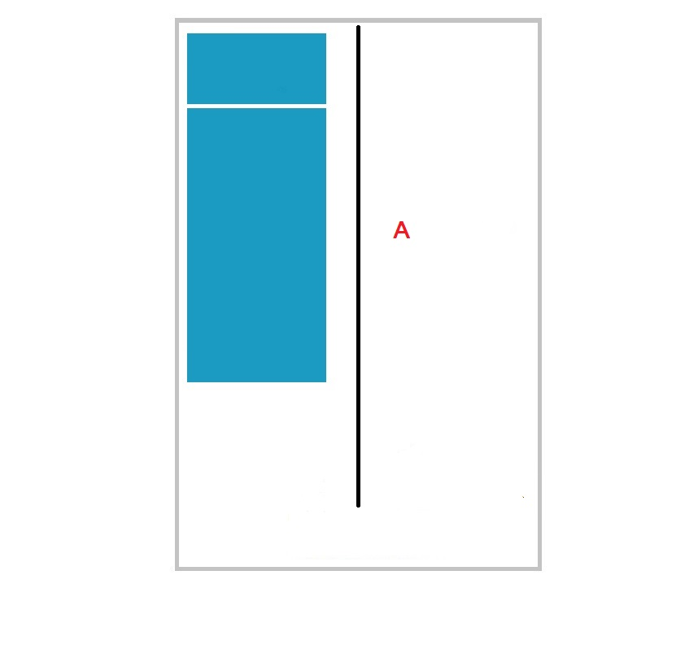

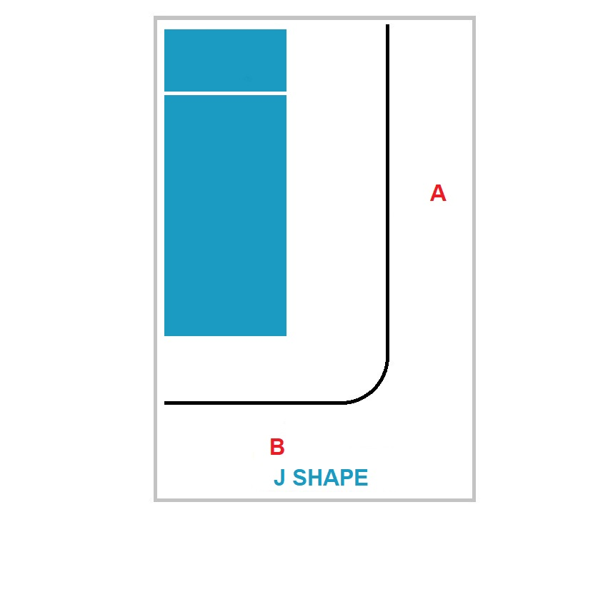

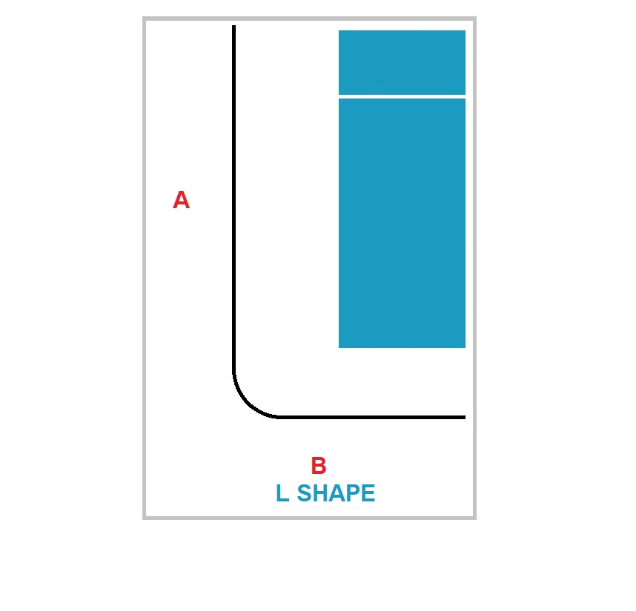

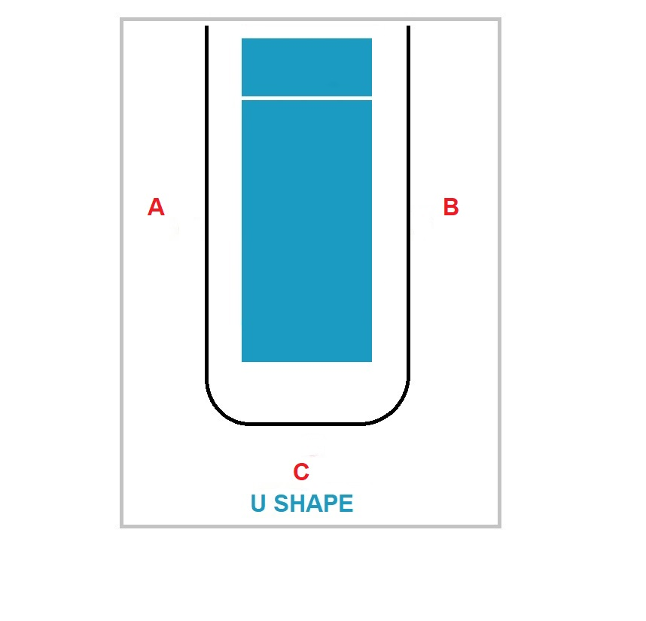

**PLEASE ENTER YOUR DETAILS IN THE HIGHLIGHTED BOXES TO RECEIVE AN ACCURATE QUOTATION**

**A**

**U SHAPE**

**L SHAPE**

**J SHAPE**

**STRAIGHT**

|  |  |
| --- | --- |
| **MEASUREMENT A (cm)** |  |
| **CEILING HEIGHT (cm)** |  |
| **QUANTITY REQUIRED** |  |

|  |  |
| --- | --- |
| **MEASUREMENT A (cm)** |  |
| **MEASUREMENT B (cm)** |  |
| **CEILING HEIGHT (cm)** |  |
| **QUANTITY REQUIRED** |  |

|  |  |
| --- | --- |
| **MEASUREMENT A (cm)** |  |
| **MEASUREMENT B (cm)** |  |
| **CEILING HEIGHT (cm)** |  |
| **QUANTITY REQUIRED** |  |

|  |  |
| --- | --- |
| **MEASUREMENT A (cm)** |  |
| **MEASUREMENT B (cm)** |  |
| **MEASUREMENT C (cm)** |  |
| **CEILING HEIGHT (cm)** |  |
| **QUANTITY REQUIRED** |  |

**PLEASE PLACE AN ‘X’ IN THE BOX TO SELECT THE REQUIRED FIXING METHOD**

**FLUSH FIX**

THE TRACK IS MOUNTED FLUSH WITH

THE CEILING

|  |  |
| --- | --- |
| **SELECT** |  |

**SUSPENDED FIX**

THE TRACK IS SUSPENDED FROM DROPPER

RODS ATTACHED TO THE CEILING

|  |  |
| --- | --- |
| **SELECT** |  |

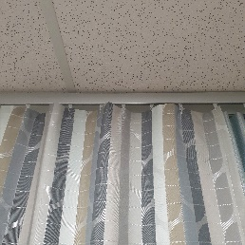

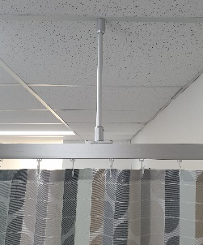

**OR**

|  |  |  |  |  |
| --- | --- | --- | --- | --- |
| **NAME:** |  |  |  |  |
| **EMAIL:** |  |  |  |  |
| **PHONE:** |  |  |  |  |

|  |
| --- |
| **ADDITIONAL INFORMATION:** |
|  |
|  |
|  |
|  |

